HOSTE D BY

Available online at [www.sciencedirect.com](http://www.sciencedirect.com/science/journal/2314808X)

**ScienceDirect**

journal homepage: [http://ees.elsevier.com/ejbas/default.asp](http://http//ees.elsevier.com/ejbas/default.asp)

egyptian journal of basic and applied sciences 2

(201 5 ) 310–31 7



**Full Length Article**

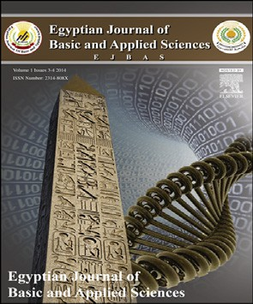**Synergistic effect of phytohormones on pigment and fine structure of chloroplasts in flag leaf of wheat plants irrigated by seawater**



***Heshmat Aldesuquy*** ***\****

*Botany Department, Faculty of Science, Mansoura University, Mansoura, Egypt*

A R T I C L E I N F O A B S T R A C T

*Article history:*

Received 25 February 2015 Received in revised form 11 May 2015

Accepted 8 July 2015

Available online 28 July 2015

*Keywords:*

Chloroplast ultrastructure Pigment

Phytohormones Seawater

Flag leaf

Plant hormones play vital roles in the ability of plants to acclimatize to varying environ- ments by mediating growth, development and nutrient allocation. The present investigation was undertaken to have some information about interactive effects of seawater salinity and some plant growth regulators (gibberellic acid, indole acetic acid or abscisic acid) on leaf area, pigment and chloroplast ultrastructure as well as saccharides and protein content of wheat flag leaf. In the majority of cases, seawater at 10 or 25% increased pigment content, particularly carotenoids. On the other hand seawater reduced leaf lamina area, Hill activ- ity and sucrose as well as polysaccharides and protein. The interactive effect of seawater and growth regulators accelerated the production of Chl a, Chl b and carotenoids by in- creasing the values of these pigment. Furthermore, grain pretreatment with gibberellic acid, indole acetic acid or abscisic acid induced marked increase in leaf lamina area, Hill activ- ity and sucrose as well as polysaccharides and protein. Irrigation of wheat plants by seawater at 10 or 25% caused dramatic changes in chloroplast ultrastructure of flag leaf. These changes include disorganized membrane system, disruption of bounding membrane, reduction in the size and number of starch grains and an increase in plastoglobuli. The presoaking of wheat grains in GA3, IAA or ABA resulted in an increase of plant tolerance against the adverse effect of seawater particularly at 10%. This resistance was estimated by the presence of normal chloroplast.

© 2015 Mansoura University. Production and hosting by Elsevier B.V. This is an open access article under the CC BY-NC-ND license (<http://creativecommons.org/licenses/by->

nc-nd/4.0/).

# Introduction

Plants’ behavioral response to salinity is complex, and differ- ent mechanisms are adopted by plants when they encounter salinity. However, plant species have different degrees of

sensitivity or tolerance to salinity [1,2]. Irrigation of wheat plants by seawater at 25% caused marked decrease in leaf area, pigment content, Hill activity and photosynthetic efficiency of wheat flag leaf at ear emergence [3].

Flag leaves have, for a long time, been considered as an im- portant source to be supplied to the ears of rice [4] and wheat

* Tel.: 00201006573700.

*E-mail address:* [heshmat-aldesuquy@hotmail.com](mailto:heshmat-aldesuquy@hotmail.com). <http://dx.doi.org/10.1016/j.ejbas.2015.07.002>

2314-808X/© 2015 Mansoura University. Production and hosting by Elsevier B.V. This is an open access article under the CC BY-NC-ND license ([http://creativecommons.org/licenses/by-nc-nd/4.0/).](http://creativecommons.org/licenses/by-nc-nd/4.0/))

egyptian journal of basic and applied sciences 2

(201 5 ) 310–31 7

**311**

[2]. Pigment content which could be regarded as a criterion for photosynthetic activities were markedly affected by salt stress in the maize plants [5], in wheat [2], in broad bean [6] and in sorghum [7]. On the other hand, salinity decreased pigment in spinach [8], in black gram [9] and in wheat [10].

Plant hormones play vital roles in the ability of plants to acclimatize to varying environments by mediating growth, de- velopment and nutrient allocation. Hormones move through specific pathways to regulatory sites where they respond to stress at low concentration. All biological activities are di- rectly or indirectly affected by phytohormones [11]. Gibberellic acid and indolyl-3-acetic acid increased pigment content of sa- linized plants (i.e. in grasses [12], in kidney bean [13], in broad bean [6]). Furthermore, the interaction between salinity and phy- tohormones increased the number of chloroplasts per mesophyll cell of wheat flag leaf [12].

Plant growth regulator, kinetin, is known to modulate the key physiological processes under abiotic stresses in differ- ent crops [14]. Phytohormones have been reported to be involved in stress responses and adaptation [15,16], mainly abscisic acid (ABA), ethylene and salicylic acid (SA). However, much less is known about the role of cytokinins, gibberellins and auxins, traditionally not related to stress responses except for some few examples. One of the principal topics studied in plant re- sponses to abiotic stress, especially drought and salinity, is ABA accumulation. The biosynthesis and redistribution of this hormone is one of the fastest plant responses to abiotic stresses, causing stomatal closure to reduce water loss via transpira- tion and eventually limiting cellular growth [16].

Only few studies have been devoted to the influence of water stress in the plant cell organelles. Ionic additives such as NaCl and KCl caused a significant swelling of thylakoid mem- branes in chloroplast of *Kandelia candel* [17]. The most outstanding feature observed were the presence of a distinc- tive ultrastructure organization.

The most outstanding features observed were the pres- ence of turgid cells with enlarged amyloplasts and mitochondria [18]. In cotton, salinity induces shrinkage, lamellae swelling of chloroplasts and condensed mitochondria, with oxalate crys- tals occurring in the vacuole [19]. Furthermore, Aldesuquy et al.

[2] irrigated wheat plants by seawater at 25% which caused marked decrease in leaf area, pigment content, Hill activity and photosynthetic efficiency of wheat flag leaf at ear emer- gence. Grain priming with kinetin, spermine or their interaction alleviated the adverse effect of seawater stress by stimulat- ing leaf area expansion, pigment production as well as photosynthetic activity. From transmission electron micros- copy micrographs, a continuous “end-to-end” distribution of regular (oval or elliptical) chloroplasts around the cell’s pe- riphery was observed in flag leaf mesophyll cells of control wheat plants. Conversely for seawater-stressed plants, the ir- regular spherical chloroplasts appeared “bulbous” and discrete; the cells also displayed extensive but thin peripheral cyto- plasmic regions devoid of chloroplasts. Grain presoaking in

0.1 mM kinetin caused the chloroplast of stressed wheat plants to be more regular, with organized membrane system, large starch grains and projections in the form of tails. Further- more, ultrastructure analysis cleared that grain priming with spermine, either alone or in combination with kinetin, caused the chloroplast in flag leaf mesophyll cells of stressed wheat

plants to be more regular in shape with more starch grains. The changes in pigment content and photosynthetic activity of flag leaf appeared to depend mainly on chloroplast ultra- structure and its numbers, showing a positive correlation between chloroplast number and pigment content.

It is an urgent task of plant biologists to explore suitable mechanisms of developing salt tolerant crop plants that can produce sufficient yield under adverse condition. The present investigation was undertaken to have some information about interactive effects of seawater salinity and some plant growth regulators (gibberellic acid, indole acetic acid or abscisic acid) on the pigment and chloroplast ultrastructure of wheat flag leaf.

# Materials and methods

## *Plant material and growth conditions*

For soaking experiment, a homogenous sample of wheat grains (Sakha 69) was selected. The grains were surface sterilized by soaking in 0.01 M HgCI2 solution for 3 minutes and washed thor- oughly with distilled water. The sterilized grains were divided into 4 sets. Grains of the 1st set were soaked in distilled water, while the grains of 2nd, 3rd, and 4th sets were soaked in gib- berellic acid (GA3) at 50 mg/L, indol-3-yl-acetic acid (IAA) at 5 mg/L and abscisic acid (ABA) at 1 mg/L, respectively for about 12 hours. The selection of the applied doses as well as the time of presoaking was based on preliminary experiments carried out in our laboratory for studying the effect of the provided growth regulators on the growth of different treated wheat plants by seawater [6].

After soaking, all grains were thoroughly washed with dis- tilled water and then sowed (15 grains per pot) in earthenware pots (30 cm in diameter) filled with 5 kg soil (sand, clay 2/1 v/v). The plants were subjected to natural day/night conditions (mean minimum/maximum air temperature and relative hu- midity were 15/25 °C and 35/45%; respectively) at mid-day during the experimental period. The plants in all sets were irrigated to field capacity by tap water. After two weeks, only five uniform seedlings were left in each pot. The plants of each set were divided into three groups (no irrigation with seawater, 10 % ir- rigation with seawater and 25% irrigation with seawater). The

standard seawater contained [kg m−3]: Cl–, 21.6; Na+, 11.1; SO −2,

4

2.85; K+, 0.49; P3–, 16.6; salinity was 38.5 g kg−1; pH = 8.1 and elec-

tric conductivity (EC), 47 mmhos cm. After thinning and before heading, the plants received 35 Nm−2 as ammonium nitrate and 35 Pm−2 as super phosphate. At heading stage (84 days from

sowing), flag leaf of wheat plants were used for estimation of pigment as well as electron microscopical examination.

Leaf lamina area was calculated according to the equa- tion followed by Quarrie and Jones [20]. Saccharides were determined as method adopted by Riazi et al. [21]. Protein content was estimated according Bradford [22].

## *Estimation of pigment and Hill reaction activity*

The plant photosynthetic pigment (chlorophyll a, b and ca- rotenoids) were determined according to Metzner et al. [23],

**312** egyptian journal of basic and applied sciences 2

(201 5 ) 310–31 7

while Hill activity assay was carried out as described by Arnon [24].

## *Electron microscopy*

This method was the same as Baka [25]. At heading stage (84 days from sowing), flag leaf of wheat plants were used in the present study. Normal green leaves of untreated plants were selected, together with those treated with seawater or seawa- ter and growth regulating substances. Tissues from between the veins were cut under a fixative containing 2.5% glutaral- dehyde in 0.1 M sodium cacodylate buffer at room temperatures and then washed three times in 0.1 M sodium cacodylate buffer at pH 7.0. The segments were left in the same fixative for 24 hours at room temperature and then washed three times in

0.1 M buffer over one hour. After washing, the segments were post fixed in 1% osmium trioxide in the same buffer, dehy- drated in graded series of ethanol and embedded in Araldite. Ultra thin sections were cut using JUN-5 Ultra microtome, stained by 2% aqueous uranyl acetate followed by lead citrate [26]. The ultra thin sections were examined and photographed by JUN-5G electron microscope.

## *Statistical analysis*

Statistical measurements were performed in triplicates and the means are reported. A test for significant differences (one way

ANOVA) between means at p ≤ 0.05 was performed using least

significant difference (LSD) test [27].

appeared to be non-significantly affected by seawater treat- ments. Seawater at 25% induced marked depletion (p ≤ 0.01) in Chl a content as well as Hill activity wheat flag leaf (Table 1).

Furthermore, irrigation of wheat plants by seawater caused marked reduction (p ≤ 0 .01) in sucrose, polysaccharides and protein content of wheat plants (Tables 1 and 2).

The interaction effect of seawater and GA3, IAA or ABA sig- nificantly accelerated the expansion of flag leaf area and

formation of Chl a, Chl b and carotenoids (p ≤ 0.01) in flag leaf.

Furthermore, these hormones induced additional increases in pigment contents particularly Chl a and Chl b of seawater- treated plants and Hill reaction activity (Tables 1 and 2). Grain

pretreatment with gibberellic acid, indole acetic acid or ab- scisic acid induced marked increase (p ≤ 0.01) in sucrose and polysaccharides as well as protein.

## *3.2. Changes in chloroplast ultra-structure*

Electron microscopical examination revealed that the chloro- plast from mesophyll cells of untreated plant show well developed membrane structure with very dense stacks of grana, intergranal lamellae and chloroplast-bounding membrane with starch grains and few plastoglobuli (Fig. 1).

Leaves from plants treated with 10% seawater showed more or less spherical chloroplasts with disorganized membrane system and disruption of bounding membrane (Fig. 2). Also, at this concentration, the cytoplasm was more vacuolated, with the protoplasm including different organelles moved apart from the cell wall and the tonoplast being distorted (Fig. 2).

Irrigation of wheat plants with seawater at 25% revealed the

appearance of irregularly shaped chloroplasts. An invagina-

# Results

## *Changes in leaf area, pigment, Hill activity,* saccharides and protein

Seawater at 10 or 25% caused marked increase (p ≤ 0 .01) in leaf area and carotenoids content of wheat flag leaf after com-

plete emergence of spikes. On the other hand, Chl a content

tion of cytoplasmic inclusions inside chloroplasts was observed. Disorganized membrane system inside the chloroplasts was also noticed (Fig. 3).

Grain presoaking in GA3 caused an increase in grana of chlo- roplasts of untreated wheat plants (Fig. 4). An increase in plastoglobuli was also observed. In some cases divided chlo- roplasts were noticed (Fig. 5). Grain presoaking in GA3 and irrigation of wheat plants with low concentration of

|  |  |  |  |  |  |
| --- | --- | --- | --- | --- | --- |
| **Table 1 – Effect of grain presoaking in GA3, IAA or ABA on leaf area (cm2/leaf), sucrose, polysaccharides and proteins content in flag leaf (g kg−1 DM) of wheat plants irrigated by seawater.** | | | | | |
| Parameter  Presoaking seawater (%) treatments | | Leaf area (cm2/leaf) | Sucrose (g kg−1 DM) | Polysaccharides (g kg−1 DM) | Protein (g kg−1 DM) |
| **NO** | 0 | 40.230 | 11.253 | 129.680 | 83.641 |
| 10 | | 39.124 | 9.894 | 125.741 | 79.732 |
| 25 | | 38.342 | 7.432 | 123.924 | 77.802 |
| **+ GA3** | 0 | 40.012 | 10.987 | 128.987 | 83.627 |
| 10 | | 43.345 | 13.547 | 134.725 | 85.922 |
| 25 | | 45.221 | 11.383 | 132.048 | 84.705 |
| **+ IAA** | 0 | 40.643 | 11.476 | 129.573 | 84.211 |
| 10 | | 50.720 | 15.723 | 135.880 | 87.537 |
| 25 | | 47.510 | 13.092 | 133.781 | 84.795 |
| **+ ABA** | 0 | 40.114 | 10.985 | 128.072 | 83.961 |
| 10 | | 42.561 | 12.987 | 132.780 | 85.380 |
| 25 | | 41.572 | 11.912 | 130.987 | 83.99 |
| **LSD** | **p < 0.01** | 0.230 | 0.576 | 1.112 | 1.047 |

egyptian journal of basic and applied sciences 2

(201 5 ) 310–31 7

**313**

|  |  |  |  |  |  |
| --- | --- | --- | --- | --- | --- |
| **Table 2 – Effect of grain presoaking in GA3, IAA or ABA on the pigment content (mg g−1f.wt) and Hill reaction activity [mmol (DCPIP) Kg−1(chl)**  **s−1] in flag leaf of wheat plants irrigated by seawater.** | | | | | |
| Parameter  Presoaking seawater (%) treatments | Chl a | Chl b | Carotenoids | Total pigment | Hill reaction |
| **NO** 0 | 2.12 | 0.84 | 0.68 | 3.64 | 80.213 |
| 10 | 2.10 | 0.89 | 0.74 | 3.73 | 67.521 |
| 25 | 2.20 | 0.68 | 0.92 | 3.80 | 56.993 |
| **+ GA3** 0 | 2.23 | 0.68 | 0.71 | 3.62 | 80.734 |
| 10 | 2.52 | 0.98 | 0.72 | 4.22 | 84.524 |
| 25 | 3.35 | 1.31 | 1.04 | 5.70 | 74.342 |
| **+ IAA** 0 | 1.89 | 0.75 | 0.57 | 3.21 | 82.526 |
| 10 | 2.93 | 1.72 | 0.88 | 5.53 | 87.742 |
| 25 | 2.69 | 0.92 | 0.78 | 4.39 | 78.324 |
| **+ ABA** 0 | 2.33 | 0.91 | 0.72 | 3.96 | 79.234 |
| 10 | 2.54 | 0.98 | 0.78 | 4.30 | 81.522 |
| 25 | 2.28 | 0.91 | 0.80 | 3.99 | 62.773 |
| **LSD p < 0.01** | 0.120 | 0.057 | 0.032 | 0.047 | 1.112 |

seawater (10%) induced the appearance of projections from chlo- roplasts, the presence of starch grains and the reduction in the number of plastoglobuli. No changes in the lamellar system of chloroplasts were detected (Fig. 6). The interactive effect of high concentration of seawater (25%) and GA3 caused disor- ganization in lamellar system of chloroplast and the appearance of cytoplasmic inclusions (Fig. 7).

Grain pretreatment with IAA induced normal chloroplast with organized lamellar system in control untreated wheat plants (Fig. 8). The regeneration of chloroplasts was the most remarkable feature at this treatment (Fig. 9). Regenerated chlo- roplast was characterized by undifferentiated lamellae and large central storm free of lamellae (Fig. 9). Grain priming with IAA and irrigation of wheat plants with seawater (10%) led to an increase of projections of chloroplasts which appeared as tails. In some positions, these tails were completely separated from mature chloroplasts which may be due to the plane of sec- tioning. In this treatment chloroplast was characterized by spherical shape, the absence of plastoglobuli and the

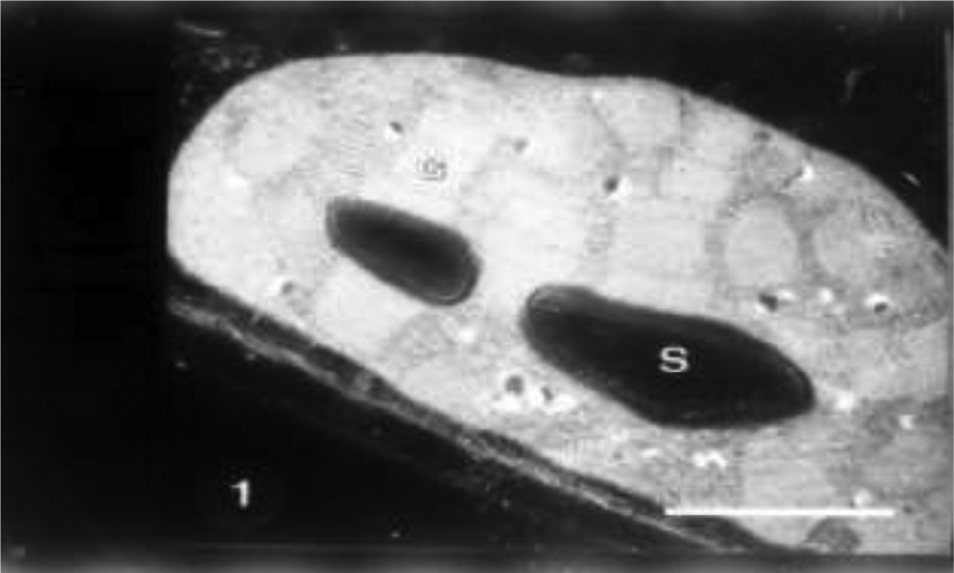

**Fig. 1 – A chloroplast from untreated wheat plant (control) showing an organized membrane system including grana**

**(G). Starch grains (S) and few plastoglobuli (arrowhead) are also observed. Bar = 1.0 um.**

presence of starch grains (Fig. 10). Indole acetic acid pretreat- ment caused an increase in grana and plastoglobuli and the presence of starch grains in seawater-treated plants particu- larly with 25% (Fig. 11).

Abscisic acid pretreatment resulted in a plant character- ized by a large chloroplast containing large amounts of grana that nearly filled most of the stroma. Starch grains, few plastoglobuli and organized chloroplast envelope were also de- tected in control plants (Fig. 12). Grain presoaking in ABA and irrigation of wheat plants with 10% seawater led to no re- markable changes in the chloroplasts. The increase in grana number, the presence of starch grains, the occurrence of few plastoglobuli and organized bounding membrane were ob- served (Fig. 13). The interactive effect of abscisic acid and seawater at 25% revealed the presence of high percentage of plastoglobuli, increased grana number and presence of chlo- roplast tails (Fig. 13).

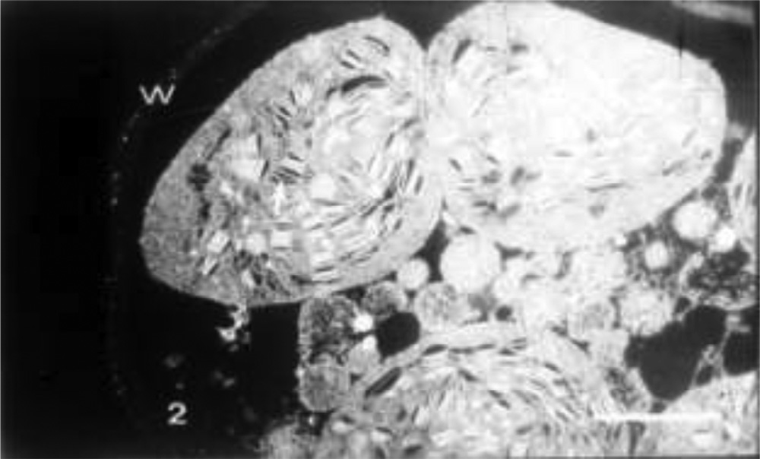

**Fig. 2 – Chloroplasts from wheat plant treated with 10% seawater showing their globoid shape, disorganized membrane system with swollen thylakoids (arrow). Note that the protoplasm is moved away from the cell wall (W). Note also the absence of starch grains and highly vacuolated cytoplasm. Bar = 2.0 um.**

**314** egyptian journal of basic and applied sciences 2

(201 5 ) 310–31 7

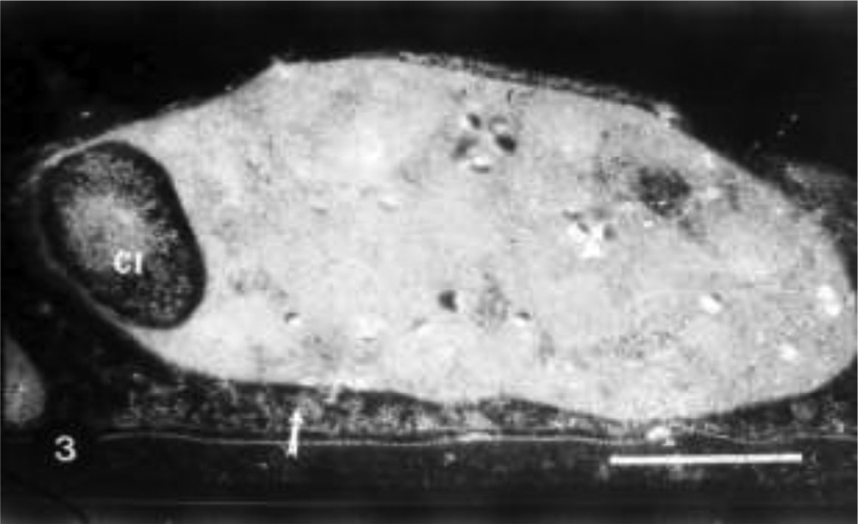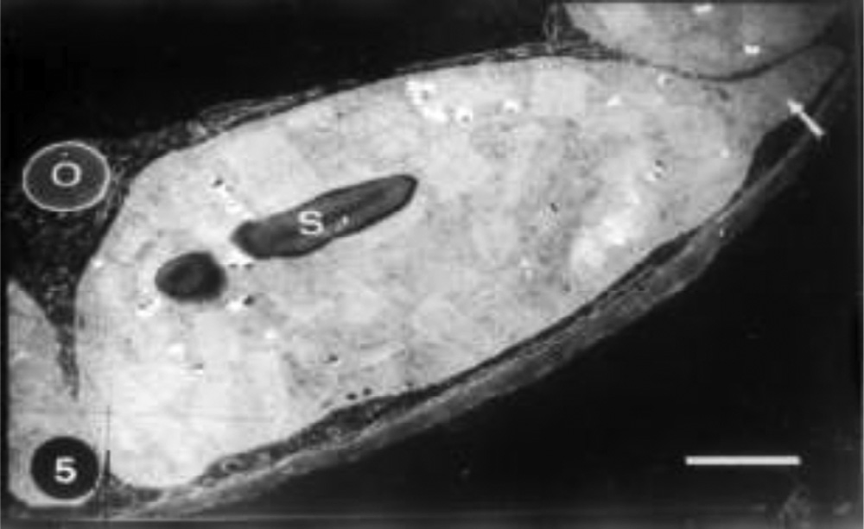

**Fig. 3 – A chloroplast from wheat plant treated with 25% seawater showing a disorganized membrane system and few plastoglobuli (arrowhead). Note the cytoplasmic inclusion (CI). Note also the granulated cytoplasm (arrow) and the absence of starch grains. Bar = 1.0 um.**

**Fig. 5 – A chloroplast from wheat plant treated with GA3 and 10% seawater showing normal chloroplast with organized membrane system and starch grains (S). Note the chloroplast projection (arrow). Note also an oleosome**

**(O) dislocated within the cell cytoplasm. Bar = 1.0 um.**

# Discussion

The reduction of cell expansion of flag leaf area due to sea- water salinity may result from the decrease in cell wall extensibility [3]. The marked decrease in leaf area in re- sponse to seawater irrigation was mitigated when the grains were soaked in GA3, IAA and ABA. Plant growth hormones may be involved directly in leaf expansion and development [28]. The simulative effect of seawater on pigments content of wheat flag leaf particularly the carotenoids might be due the fact that salinity led to an increase in the number of chloro- plast mesophyll cells. These results are in accordance with the results of Chavan and Karadge [29] on wheat [12], on *Vicia faba*

[6] and on wheat [30]*.* The meditative effect of GA3, IAA or ABA on pigment formation as well as Hill activity in flag leaf of wheat plants irrigated by seawater may explain the fact that these hormones may retard the senescence of flag leaf and this ad- vantage will keep it green for a prolonged time. These effects

became clear particularly through the effect of these pro- vided hormones on ultrastructure of chloroplast of flag leaf. Furthermore, these hormones may increase plastid biogen- esis within flag leaf [3].

The observed decline in sucrose and polysaccharides as well as protein of flag leaf of wheat plants irrigated with seawater may probably be due to their export to developing grains within the emerged spikes. Furthermore, the additional increase in pigment and Hill activity inconsistent with the exogenous ap- plication of hormones may be the reason of massive increase in saccharides and protein [3].

Chloroplast showed disorganized lamellar system such as regular stacking of grana and intergranal lamellae. These results are in agreement with those obtained by Gunning and steer

[31] who proposed that greater stacking of grana may confer an advantage by providing a suitable environment for energy transfer (photosystem I and photosystem II). Kaplan and Arntzen [32] also suggested that stacking has resulted in

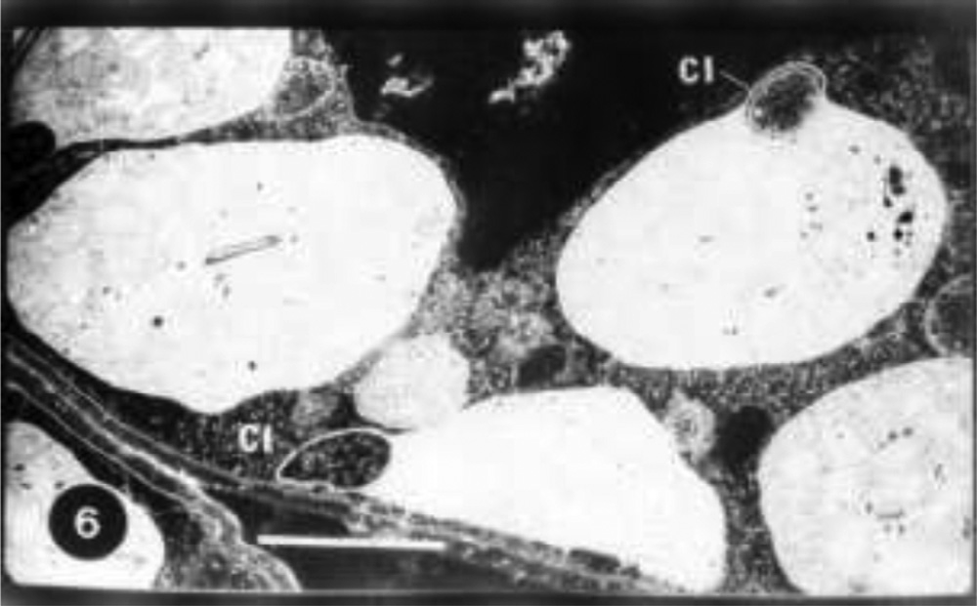

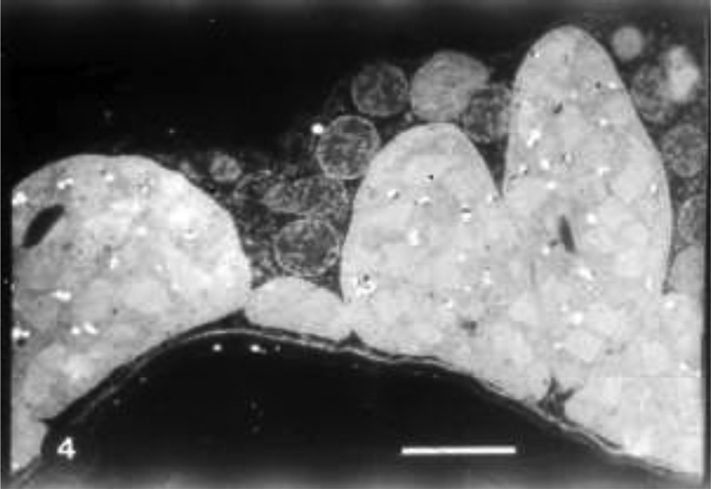**Fig. 4 – Chloroplasts from wheat plant treated with GA3 showing an organized membrane system and cytoplasm. Bar = 2.0 um.**

**Fig. 6 – Chloroplast from wheat plant treated with GA3 and 25% seawater showing their irregular shape with disorganized membrane system. Note cytoplasmic inclusions (CI). Bar = 2.0 um.**

egyptian journal of basic and applied sciences 2

(201 5 ) 310–31 7

**315**

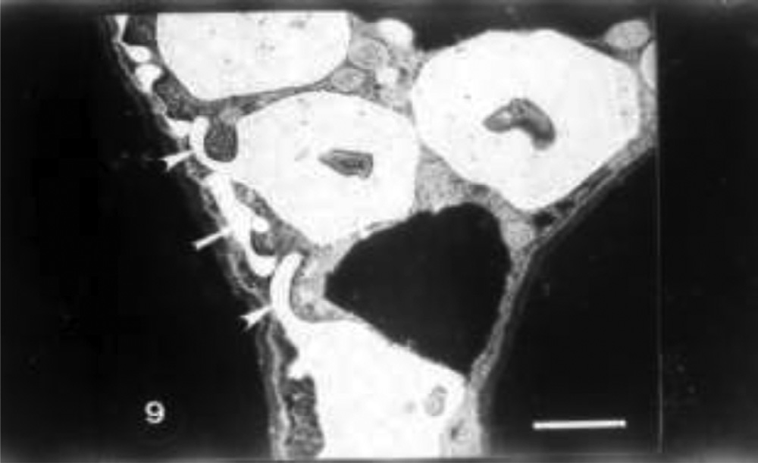

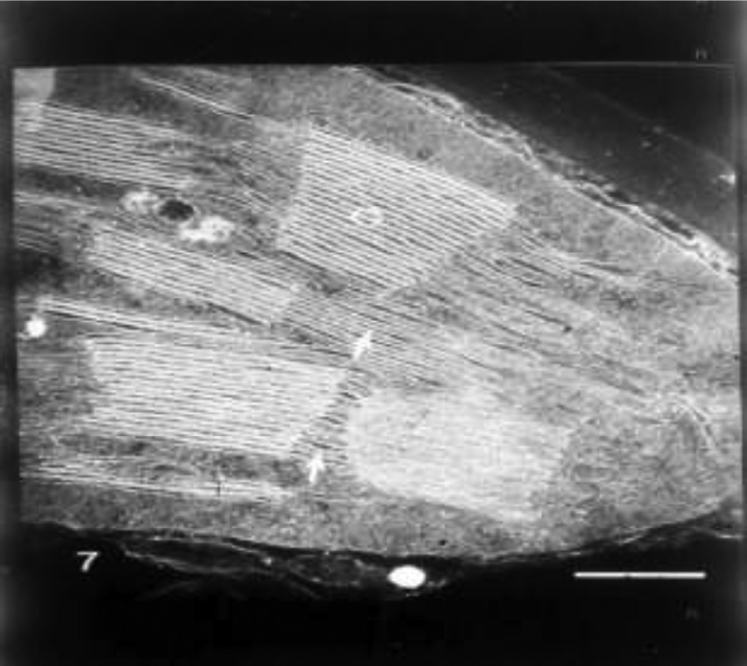**Fig. 7 – A part of chloroplast from wheat plant treated with IAA showing normal stacks of grana (G) and intergranal lamellae (arrows). Bar = 0.25 um.**

**Fig. 9 – Chloroplasts from wheat plant treated with IAA and 10% seawater showing their spherical shape with projections (arrow heads). Note separated projection (arrow). Bar = 2.0 um.**

shrinkage, lamellae swelling and condensed mitochondria in cotton plants. Hawing and Chen [17] added that ionic addi- tives such as NaCI and KCI caused significant swelling of

thylakoid membranes in chloroplasts of *Kandelia candel*. Fur-

thermore, Aldesuquy [30] found that irrigation of wheat plants

improved control of light harvesting and photochemical operations.

The greater stacking grana induced by hormonal treat- ment particularly GA3 may explain the accumulation of carotenoid in wheat flag leaf of seawater treated plants. These results are in agreement with those obtained by Weir and Benson [33] who suggested that the accumulation of carot- enoid as a result of stacking may protect chlorophyll from bleaching by light at high intensities.

Chloroplasts seem to be the organelles more sensitive to stress. Our study revealed that seawater salinity induced dis- ruption of membrane system of chloroplast and high vacuolated cytoplasm. These results fit well the observations of Blumenthal- Goldschmidt and Poljakoff-Mayber [34] who found that salinity caused swelling of chloroplasts and mitochondria and exten- sive vacuolization with distortion of tonoplast in *Atriplex*. Furthermore, Gausman et al. [19] reported that salinity induces

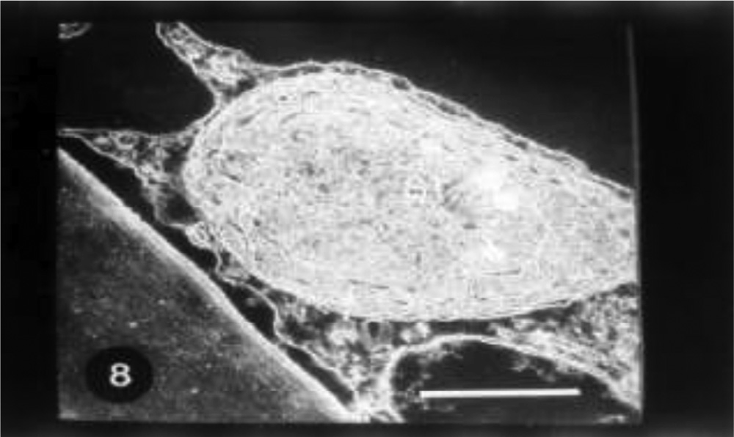

**Fig. 8 – A regenerated chloroplast from wheat plant treated with IAA showing few membranes (arrow). Note the central stroma (ST) is free membranes. Bar = 0.5 um.**

with 25% seawater induced dramatic changes in chloroplasts and oleosomes particularly after 21 days post-anthesis. They revealed that there were slight differences between two wheat cultivars in response to seawater at 10% and 14 days post- anthesis in terms of chloroplast ultrastructure. The most obvious changes were observed with the treatment with 25% seawa- ter at 21 days post-anthesis. Moreover, disorganized membrane system was identified with swollen thylakoids and many plastoglobuli were recognized in the chloroplasts in compari- son to control plants.

The present investigation revealed that seawater at 25% caused a decrease in granal system. This might cause a de- crease in photosystem II activity as demonstrated by Groff et al. [35]. The alleviation of adverse effect of seawater (particu- larly at 10%) by GA3 or IAA induced more improvement to wheat plants by inducing a high rate of assimilate export out of the

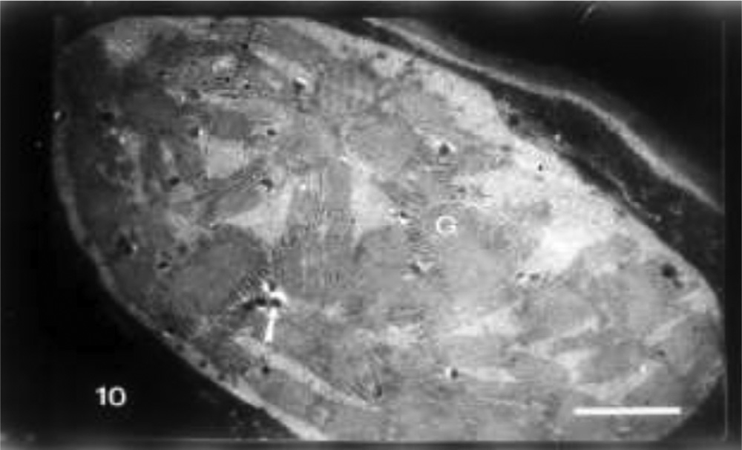

**Fig. 10 – Chloroplasts from wheat plant treated with IAA and 25% seawater showing condensed stacks of grana (G) nearly filled the stroma. Note few plastoglobuli (arrow). Note also the absence of starch grains. Bar = 1.0 um.**

**316** egyptian journal of basic and applied sciences 2

(201 5 ) 310–31 7

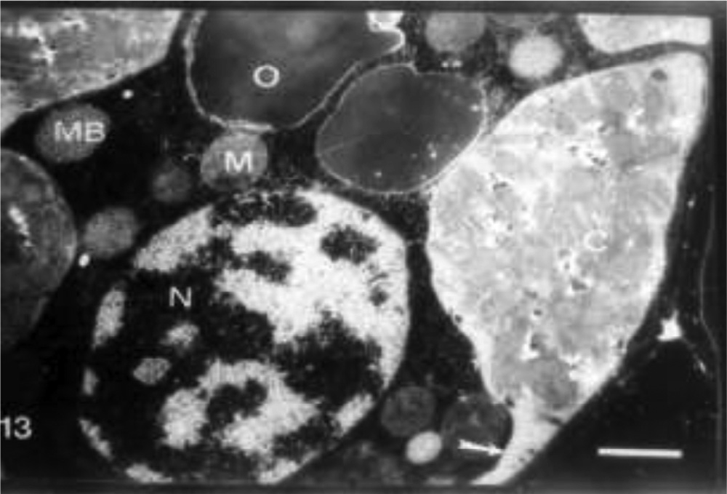

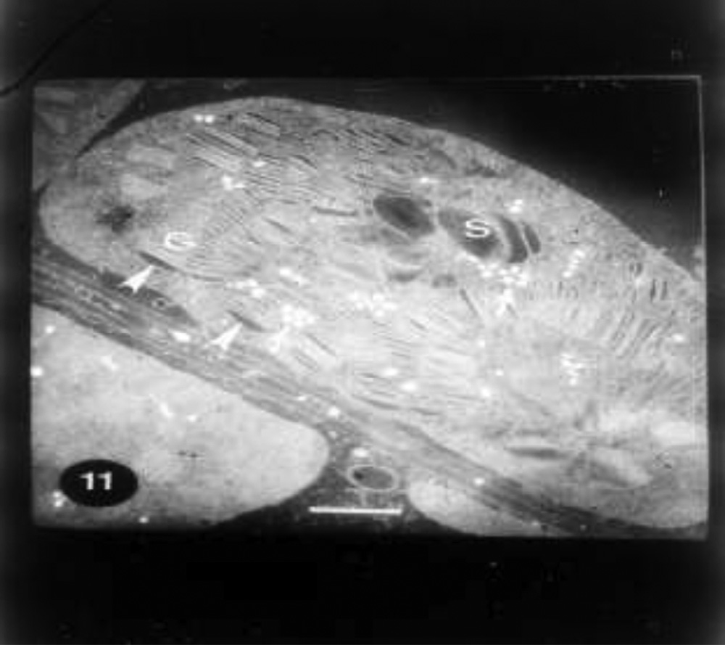**Fig. 11 – Chloroplasts from wheat plant treated with ABA showing organized stacks of grana (G) with swollen thylakoids (arrowheads). Note starch grains (S) and aggregated plastoglobuli (arrows). Bar = 0.5 um.**

**Fig. 13 – A part of cell treated with ABA and 25% seawater showing disorganized grana system of chloroplast (C), absence of starch grains and chloroplast projection (arrow). Note normal cytoplasm including micro bodies (MB), mitochondria (M), nucleus (N) and large oleosome (O).**

**Bar = 1.0 um.**

abscisic acid resulted in unstacking of thylakoid membranes,

increase in the number and size of plastoglobuli, decrease of

chloroplast size and rupture of chloroplast envelopes. Further,

leaf throughout the increasing number of starch grains in chlo- roplast of saline-treated plants. These results were in accordance with those obtained by Gunning and Steer [31].

Gibberellic acid caused a division in chloroplast of seawater- treated or untreated wheat plants. This effect might cause plastid biogenesis [12]. The mechanisms by which gibberellic acid (GA) priming could induce salt tolerance in plants are not yet clear [13].

Abscisic acid which accelerates leaf senescence [36] re- sulted in large chloroplast containing large amount of grana nearly filled most of the stroma. Furthermore, ABA increased the number of grana and plastoglobuli as well as induced or- ganized bounding membrane in seawater-treated plants. In connection with these results Hurng et al. [37] found that

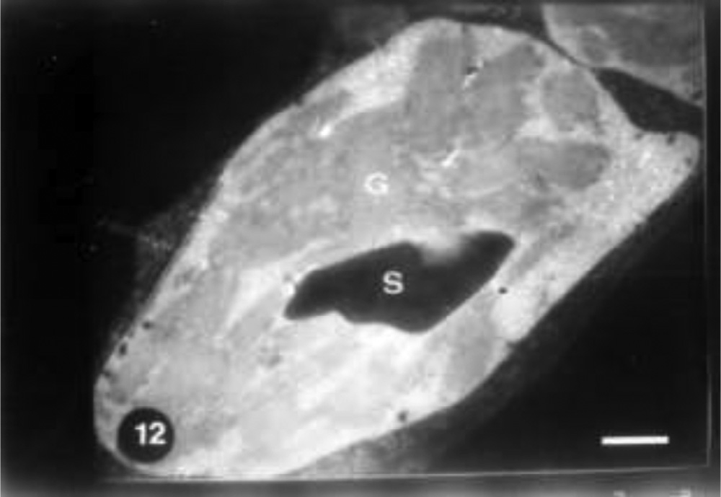

**Fig. 12 – Chloroplasts from wheat plant treated with ABA and 10% seawater showing disorganized system of grana**

**(G) and large starch grain (S). Bar = 1.0 um.**

they added that the shape of chloroplast in the presence of ABA changed from elliptical to spherical. Shah et al. [11] re- ported that abscisic acid acts as a mediator in plant responses to many stresses, including salt stress.

# Conclusions

It is not questionable that grain priming in plant hormones may retard the senescence of flag leaf and this advantage will keep it green for a prolonged time. Furthermore, these effects became clear particularly through the effect of these provided hor- mones on leaf lamina area, pigment, Hill activity, saccharides and protein as well as ultra-structure of chloroplast of flag leaf. Hence, chloroplast showed disorganized lamellar system such as regular stacking of grana and interregnal lamellae. Finally, presoaking of wheat grains in GA3, IAA or ABA resulted in an increase of wheat plants tolerance against the adverse effect of seawater particularly at 10%. This resistance was esti- mated by dramatic increase in pigment production throughout the presence of normal and healthy chloroplasts.

# Acknowledgement

The author sincerely thanks Prof. Zakaia Baka for technical support in preparing electron microscopic samples.

R E F E R E N C E S

1. [Jamil M, Lee KJ, Kim JM, Kim HS, Rha ES. Salinity reduced](http://refhub.elsevier.com/S2314-808X(15)00044-5/sr0010) [growth PS2photochemistry and chlorophyll content in](http://refhub.elsevier.com/S2314-808X(15)00044-5/sr0010) [radish. Sci. Agric. 2007;64:111–18.](http://refhub.elsevier.com/S2314-808X(15)00044-5/sr0010)

egyptian journal of basic and applied sciences 2

(201 5 ) 310–31 7

**317**

1. [Aldesuquy HS, Baka ZA, Mickky BM. Role of kinetin and](http://refhub.elsevier.com/S2314-808X(15)00044-5/sr0015) [spermine in the reversal of seawater stress-induced](http://refhub.elsevier.com/S2314-808X(15)00044-5/sr0015) [alteration in growth vigor, water relations, membrane](http://refhub.elsevier.com/S2314-808X(15)00044-5/sr0015) [characteristics and nucleic acids of wheat plants. Phyton](http://refhub.elsevier.com/S2314-808X(15)00044-5/sr0015) [2014;54:251–74.](http://refhub.elsevier.com/S2314-808X(15)00044-5/sr0015)
2. [Aldesuquy HS, Baka ZA, Mickky BM. Kinetin and spermine](http://refhub.elsevier.com/S2314-808X(15)00044-5/sr0020) [mediated induction of salt tolerance in wheat plants: leaf](http://refhub.elsevier.com/S2314-808X(15)00044-5/sr0020) [area, photosynthesis and chloroplast ultrastructure of flag](http://refhub.elsevier.com/S2314-808X(15)00044-5/sr0020) [leaf at ear emergence. Egypt J Basic & Appl Sci 2014;77–87.](http://refhub.elsevier.com/S2314-808X(15)00044-5/sr0020)
3. [Rao CN, Murty KS. Source and relationship in rice. Sci Cult](http://refhub.elsevier.com/S2314-808X(15)00044-5/sr0025) [1976;42:555–9.](http://refhub.elsevier.com/S2314-808X(15)00044-5/sr0025)
4. [El- Deep BA. The effect of plant hormones and salinity of](http://refhub.elsevier.com/S2314-808X(15)00044-5/sr0030) [some physiological activities of some plants [M.Sc. Thesis].](http://refhub.elsevier.com/S2314-808X(15)00044-5/sr0030) [Assiut, Egypt: Assiut University; 1984.](http://refhub.elsevier.com/S2314-808X(15)00044-5/sr0030)
5. [Aldesuquy HS, Gaber AM. Effect of growth regulators on *Vicia*](http://refhub.elsevier.com/S2314-808X(15)00044-5/sr0035)[*faba* plants irrigated by seawater. Leaf area, pigment content](http://refhub.elsevier.com/S2314-808X(15)00044-5/sr0035) [and photosynthetic activity. Biol Plant 1993;35:519–27.](http://refhub.elsevier.com/S2314-808X(15)00044-5/sr0035)
6. [Abo-Hamed SA. Salinity–calcium interactions on praline](http://refhub.elsevier.com/S2314-808X(15)00044-5/sr0040) [content, chlorophyll, stomata resistance and water content](http://refhub.elsevier.com/S2314-808X(15)00044-5/sr0040) [of sorghum plants. J Environ Sci 1994;8:45–60.](http://refhub.elsevier.com/S2314-808X(15)00044-5/sr0040)
7. [Robinson SP, John W, Downton S, Millhouse JA.](http://refhub.elsevier.com/S2314-808X(15)00044-5/sr0045) [Photosynthesis and ion content of leaves and isolated](http://refhub.elsevier.com/S2314-808X(15)00044-5/sr0045) [chloroplast of salt-stressed spinach. Plant Physiol](http://refhub.elsevier.com/S2314-808X(15)00044-5/sr0045) [1983;73:238–42.](http://refhub.elsevier.com/S2314-808X(15)00044-5/sr0045)
8. [Ashraf M. The effect of NaCI on water relations, chlorophyll,](http://refhub.elsevier.com/S2314-808X(15)00044-5/sr0050) [protein and proline contents of two cultivars of black gram](http://refhub.elsevier.com/S2314-808X(15)00044-5/sr0050) [(*Vigna mungo* L.). Plant Soil 1989;119:205–10.](http://refhub.elsevier.com/S2314-808X(15)00044-5/sr0050)
9. [Mankarios AT, Aldesuquy HS, Awad HA. Effect of some](http://refhub.elsevier.com/S2314-808X(15)00044-5/sr0055) [antitranspirant on growth, metabolism and productivity of](http://refhub.elsevier.com/S2314-808X(15)00044-5/sr0055) [saline-treated wheat plants. I. Shoot growth, leaf expansion](http://refhub.elsevier.com/S2314-808X(15)00044-5/sr0055) [and photosynthetic pigment. J Environ Sci 1995;10:75–87.](http://refhub.elsevier.com/S2314-808X(15)00044-5/sr0055)
10. [Shah F, Lixiao N, Yutiao C, Chao W, Dongliang X, Shah S,](http://refhub.elsevier.com/S2314-808X(15)00044-5/sr0060) [et al. Crop plant hormones and environmental stress.](http://refhub.elsevier.com/S2314-808X(15)00044-5/sr0060) [Sustain Agric Rev 2015;15:371–400.](http://refhub.elsevier.com/S2314-808X(15)00044-5/sr0060)
11. [Aldesuquy HS. Growth and pigment content of wheat as](http://refhub.elsevier.com/S2314-808X(15)00044-5/sr0065) [influenced by the combined effects of salinity and growth](http://refhub.elsevier.com/S2314-808X(15)00044-5/sr0065) [regulators. Biol Plant 1992;34:275–83.](http://refhub.elsevier.com/S2314-808X(15)00044-5/sr0065)
12. [Shaddad MA, Heikal MM. Interactive effect of GA3 and](http://refhub.elsevier.com/S2314-808X(15)00044-5/sr0070) [salinity on kidney bean. Bull Fac Sci Assiut Univ 1983;II:65–](http://refhub.elsevier.com/S2314-808X(15)00044-5/sr0070) [81.](http://refhub.elsevier.com/S2314-808X(15)00044-5/sr0070)
13. [Lalarukh M, Arslan A, Azeem M, Hussain M, Akbar M, Yasin](http://refhub.elsevier.com/S2314-808X(15)00044-5/sr0075) [A, et al. Growth stage-based response of wheat (*Triticum*](http://refhub.elsevier.com/S2314-808X(15)00044-5/sr0075)[*aestivum* L.) to kinetin under water-deficit environment:](http://refhub.elsevier.com/S2314-808X(15)00044-5/sr0075) [pigments and gas exchange attributes. Acta Agric Scand B](http://refhub.elsevier.com/S2314-808X(15)00044-5/sr0075) [Soil Plant Sci 2014;64:501–10.](http://refhub.elsevier.com/S2314-808X(15)00044-5/sr0075)
14. [Shateriana J, Waterera D, Jong HD, Taninoa KK. Differential](http://refhub.elsevier.com/S2314-808X(15)00044-5/sr0080) [stress responses to NaCl salt application in early- and late-](http://refhub.elsevier.com/S2314-808X(15)00044-5/sr0080) [maturing diploid potato (*Solanum* sp.) clones. Environ Exp](http://refhub.elsevier.com/S2314-808X(15)00044-5/sr0080) [Bot 2005;54:202–12.](http://refhub.elsevier.com/S2314-808X(15)00044-5/sr0080)
15. [Peleg Z, Blumwald E. Hormone balance and abiotic stress](http://refhub.elsevier.com/S2314-808X(15)00044-5/sr0085) [tolerance in crop plants. Curr Opin Plant Biol 2011;14:290–5.](http://refhub.elsevier.com/S2314-808X(15)00044-5/sr0085)
16. [Hwang YH, Chen SC. Effect of toxicity and additives to the](http://refhub.elsevier.com/S2314-808X(15)00044-5/sr0090) [fixative on ultrastructure of mesophyllous cells in *Kandelia*](http://refhub.elsevier.com/S2314-808X(15)00044-5/sr0090)[*candel* (L.) druce (Rhizophoraceae). Bot Bull Acad Sinica](http://refhub.elsevier.com/S2314-808X(15)00044-5/sr0090) [1997;38:21–8.](http://refhub.elsevier.com/S2314-808X(15)00044-5/sr0090)
17. [Munoz GE, Barlow PW, Plalma B. Effect of seawater on roots](http://refhub.elsevier.com/S2314-808X(15)00044-5/sr0095) [of *Prosopis alba* (Leguminosae) seedlings. Phyton (Buenos](http://refhub.elsevier.com/S2314-808X(15)00044-5/sr0095) [Aires) 1996;59:55–63.](http://refhub.elsevier.com/S2314-808X(15)00044-5/sr0095)
18. [Gausman HW, Baur PS, Porterf MP, Cardenas C. Effects of](http://refhub.elsevier.com/S2314-808X(15)00044-5/sr0100) [salt treatment of cotton plants (*Gossypium hirsutum* L.) on](http://refhub.elsevier.com/S2314-808X(15)00044-5/sr0100) [leaf mesophyll cell microstructure. Agron J 1992;64:133–6.](http://refhub.elsevier.com/S2314-808X(15)00044-5/sr0100)
19. [Quarrie SA, Jones HG. Genotype variation in leaf water](http://refhub.elsevier.com/S2314-808X(15)00044-5/sr0105) [potential, stomatal conductance and abscisic acid](http://refhub.elsevier.com/S2314-808X(15)00044-5/sr0105) [concentration in spring wheat subjected to artificial drought](http://refhub.elsevier.com/S2314-808X(15)00044-5/sr0105) [stress. Ann Bot 1979;44:323–32.](http://refhub.elsevier.com/S2314-808X(15)00044-5/sr0105)
20. [Riazi A, Matsuda K, Arslan A. Water stress induced changes](http://refhub.elsevier.com/S2314-808X(15)00044-5/sr0110) [in concentrations of proline and other solutes in growing](http://refhub.elsevier.com/S2314-808X(15)00044-5/sr0110) [regions of young barley leaves. J Exp Bot 1985;36:1716–25.](http://refhub.elsevier.com/S2314-808X(15)00044-5/sr0110)
21. [Bradford MM. A rapid and sensitive method for the](http://refhub.elsevier.com/S2314-808X(15)00044-5/sr0115) [quantitation of microgram quantities of protein utilizing the](http://refhub.elsevier.com/S2314-808X(15)00044-5/sr0115) [principle of protein dye-binding. Anal Biochem 1976;72:248–](http://refhub.elsevier.com/S2314-808X(15)00044-5/sr0115) [51.](http://refhub.elsevier.com/S2314-808X(15)00044-5/sr0115)
22. [Metzner H, Rau H, Senger H. Untersuchungen zur](http://refhub.elsevier.com/S2314-808X(15)00044-5/sr0120) [Synchronisierbarkeit Einzelner Pigment- Mangel- Mutanten](http://refhub.elsevier.com/S2314-808X(15)00044-5/sr0120) [von *Chlorella*. Planta 1965;65:186–94.](http://refhub.elsevier.com/S2314-808X(15)00044-5/sr0120)
23. [Arnon DI. Copper enzymes in isolated chloroplasts:](http://refhub.elsevier.com/S2314-808X(15)00044-5/sr0125) [polyphenoloxidase in Beta vulgaris. Plant Physiol 1949;24:1–](http://refhub.elsevier.com/S2314-808X(15)00044-5/sr0125) [15.](http://refhub.elsevier.com/S2314-808X(15)00044-5/sr0125)
24. [Baka ZAM. Responses of plant tissues to infection by rust](http://refhub.elsevier.com/S2314-808X(15)00044-5/sr0130) [fungi: fine structure, cytochemistry and autoradiography](http://refhub.elsevier.com/S2314-808X(15)00044-5/sr0130) [[Ph.D. Thesis]. England: University of Sheffield; 1987.](http://refhub.elsevier.com/S2314-808X(15)00044-5/sr0130)
25. [Reynodlls ES. The use of lead citrate at a high pH as an](http://refhub.elsevier.com/S2314-808X(15)00044-5/sr0135) [electron-opaque stain in electron microscopy. J Cell Biol](http://refhub.elsevier.com/S2314-808X(15)00044-5/sr0135) [1963;17:208–12.](http://refhub.elsevier.com/S2314-808X(15)00044-5/sr0135)
26. [Snedecor GW, Cochran WG. Statistical method. 6th ed. New](http://refhub.elsevier.com/S2314-808X(15)00044-5/sr0140) [Delhi: Oxford and IBH Publishing Co.; 1976.](http://refhub.elsevier.com/S2314-808X(15)00044-5/sr0140)
27. [Herzog H. Relation of source and sink during grain filling](http://refhub.elsevier.com/S2314-808X(15)00044-5/sr0145) [period in wheat and some aspects of its regulation. Physiol](http://refhub.elsevier.com/S2314-808X(15)00044-5/sr0145) [Plant 1982;56:155–60.](http://refhub.elsevier.com/S2314-808X(15)00044-5/sr0145)
28. [Chavan P, Karadge BA. Influence of salinity on mineral](http://refhub.elsevier.com/S2314-808X(15)00044-5/sr0150) [nutrition of peanut (*Arachis hypogea*). Plant Soil 1980;54:5–12.](http://refhub.elsevier.com/S2314-808X(15)00044-5/sr0150)
29. [Aldesuquy HS. Impact of seawater salinity on ultrastructure](http://refhub.elsevier.com/S2314-808X(15)00044-5/sr0155) [of chloroplasts and oleosomes in relation to fat metabolism](http://refhub.elsevier.com/S2314-808X(15)00044-5/sr0155) [in flag leaf of two wheat cultivars during grain-filling. Plant](http://refhub.elsevier.com/S2314-808X(15)00044-5/sr0155) [Growth Regul 2015;in press.](http://refhub.elsevier.com/S2314-808X(15)00044-5/sr0155)
30. [Gunning BES, Steer MW. Ultrastructure and the biology of](http://refhub.elsevier.com/S2314-808X(15)00044-5/sr0160) [plant cells. London: Edward Arnold; 1975.](http://refhub.elsevier.com/S2314-808X(15)00044-5/sr0160)
31. [Kaplan S, Arntzen CJ. Photosynthetic membrane structure](http://refhub.elsevier.com/S2314-808X(15)00044-5/sr0165) [and function. In: Govinjee, editor. Photosynthesis, vol. l.](http://refhub.elsevier.com/S2314-808X(15)00044-5/sr0165) [Energy conversion by plant bacteria. New York: Academic](http://refhub.elsevier.com/S2314-808X(15)00044-5/sr0165) [Press; 1982. p. 65–151.](http://refhub.elsevier.com/S2314-808X(15)00044-5/sr0165)
32. [Weier TE, Benson AA. The molecular organization of](http://refhub.elsevier.com/S2314-808X(15)00044-5/sr0170) [chloroplast membranes. Am J Bot 1967;54:389–402.](http://refhub.elsevier.com/S2314-808X(15)00044-5/sr0170)
33. [Blumental-Goldschmidt S, Poljakoff-Mayber A. Effect of](http://refhub.elsevier.com/S2314-808X(15)00044-5/sr0175) [substrate salinity on growth and on submicroscopic](http://refhub.elsevier.com/S2314-808X(15)00044-5/sr0175) [structure of leaf cells of *Atriplex helium’s* L. Aust J Bot](http://refhub.elsevier.com/S2314-808X(15)00044-5/sr0175) [1968;16:469–78.](http://refhub.elsevier.com/S2314-808X(15)00044-5/sr0175)
34. [Grof CPL, Johnston M, Brownell F. Effects of sodium nutrition](http://refhub.elsevier.com/S2314-808X(15)00044-5/sr0180) [on the ultrastructure of chloroplasts of C4 plants. Plant](http://refhub.elsevier.com/S2314-808X(15)00044-5/sr0180) [Physiol 1989;89:539–43.](http://refhub.elsevier.com/S2314-808X(15)00044-5/sr0180)
35. [Baka ZAM, Aldesuquy HS. Changes in ultra structure and](http://refhub.elsevier.com/S2314-808X(15)00044-5/sr0185) [hormones of the fully senescent leaf of *Senecio aegyptius*.](http://refhub.elsevier.com/S2314-808X(15)00044-5/sr0185) [Beitr Biol Pflanzen 1991;66:271–81.](http://refhub.elsevier.com/S2314-808X(15)00044-5/sr0185)
36. [Hurng WP, Lin TL, Ren SS, Chen JC, Chen YR, Kao CH.](http://refhub.elsevier.com/S2314-808X(15)00044-5/sr0190) [Senescence of rice leaves. XIX. Ultra structure changes of](http://refhub.elsevier.com/S2314-808X(15)00044-5/sr0190) [chloroplasts. Bot Bull Acad Sinica 1988;29:75–9.](http://refhub.elsevier.com/S2314-808X(15)00044-5/sr0190)